DATABASE

**Database:** It is a collection of data in a format that can be easily accessed.

To manage these databases, **Database Management System** (DBMS) are used.



**System**

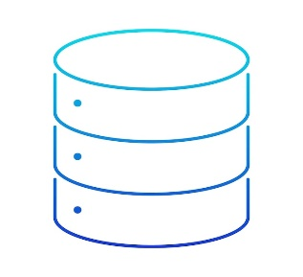

Database

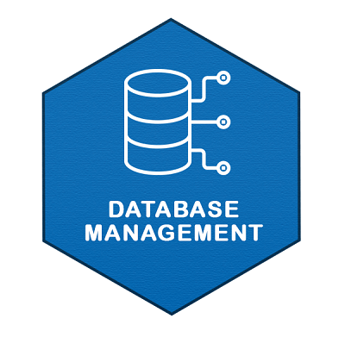

**DBMS**: It is a software used to create, manage and organize data in a structured manner.

DBMS provide an environment to store and retrieve the data in convenient and efficient manner.

Example: A university database organizes the data about student, faculty, staff etc.

**Key Features of DBMS:**

* **Data Modeling:** Tools for defining the structure and relationships of data within a database.
* **Data Storage and Retrieval:** Manages storing and accessing data, enabling efficient searching and querying.
* **Concurrency Control:** Ensures multiple users can access the database simultaneously without conflicts.
* **Data Integrity and Security:** Enforces rules for data accuracy and restricts access to authorized users only.
* **Backup and Recovery:** Provides mechanisms to back up data and restore it after system failures.

**DBMS can be classified into two types:**

1. Relational Database Management System (RDBMS)
2. Non-Relational Database Management System (NoSQL or Non-SQL)

**RDBMS:** Data is organized in the form of tables and each table has a set of rows and columns. The data are related to each other through primary and foreign keys.

Example: MySQL, Oracle, PostgreSQL

|  |  |  |
| --- | --- | --- |
| **ID** | **Name** | **Class** |
| 101 | Charlie | 9 |
| 102 | Bob | 11th |
| 103 | Alice | 10 |

**NoSQL**: Data is organized in the form of key-value pairs, documents, graphs, or column-based. These are designed to handle large-scale, high-performance scenarios.

Example: MongoDB, Redis

{

“RollNo”: 1,

“Class”: 5th,

“Name”: “Bob”

}

**SQL INTRODUCTION**

SQL stands for Structured Query Language

It is used for accessing and manipulating databases.

**What can SQL do?**

With the help of sql we can execute query, retrieve data, create database and tables, insert records, update records, delete record, create views and set permission on tales, procedure and views.

**SYNTAX**:

Select * from table_name;

NOTE: SQL keywords are not case sensitive: Select is same as SELECT.